***Solution of Algebraic &Transcendental Equations***

**Md. Mehedi Hasan**

**LECTURER, DAFFODIL international university**

***Solution of Algebraic and Transcendental equations***

In this Lesson, we have discussed about the solution of equations  where  linear, non-linear, algebraic or transcendental function. We get the solution of the equation  by using Bisection method, Newton- Raphson method and method of false position. Those methods are established based on **Intermediate Value Theorem.**

***Statement of Intermediate Value Theorem:***

***If f(x) is continuous in the interval (a, b) and if f (a) and f(b) are of opposite signs, then the***

***equation f(x) = 0 will have at least one real root between a and b.***

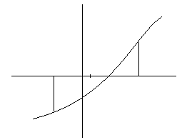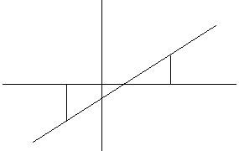

**Algebraic equation:**

An**algebraic equation** is an equation that includes one or more variables such as.

**Transcendental equation:**

An equation together with algebraic, trigonometrical, exponential or logarithmic function etc. is called transcendental equation such as .

**Solution/root:**

A solution/root of an equation is the value of the variable or variables that satisfies the equation.

**Iteration:**

Iteration is the repeated process of calculation until the desired result or approximate numerical value has come. Each repetition of the process is also called iteration and the result of one iteration is used as the starting point for the next iteration.

We are capable to find the root of *algebraic or transcendental function by using following methods:*

1. Bisection method
2. Newton Rapshon method (Newton’s Iteration method)
3. Iteration method (Method of successive approximation/Fixed-point Iteration Method)
4. Regular-Falsi method (The method of False position)
5. The secant method
6. Muller’s method
7. Ramanujan’s method *8.* Horner’s method

**Bisection Method:**

Let us suppose we have an equation of the form in which solution lies between in the range where. Also  is continuous and it can be algebraic or transcendental. If and are opposite signs, then there exist at least one real root between a and b. Let  be positive and negative. Which implies at least one root exits between a and b. We assume that root to be . Check the sign of. If  is negative, the root lies between  and. Ifis positive, the root lies between  and b.



Subsequently any one of this case occur.Or. When is negative, the root lies between and  and let the root be. Again negative then the root lies between and , let and so on. Repeat the process whose limit of convergence is the exact root. We have to stop the iteration when the value of two successive iterations are approximately equal. That is  or .



**Advantages of the bisection method:**

1. It is always convergent.
2. The error bound decreases by half with each iteration i.e., error can be controlled.
3. It is well suited to electronic Computers.
4. It is very simple method.

**Disadvantages/draw-back of the bisection method:**

1. The bisection method converges very slowly
2. It requires large number of iterations
3. The bisection method cannot detect multiple roots
4. Choosing a guess close to the root may result in needing many iterations to converge.
5. Cannot find roots of some equations such as because upper guess and lower guess always produce positive value.
6. May seek a singularity point as a root as the equation like 

**Algorithm for Bisection method:**

|  |  |
| --- | --- |
| **Steps** | **Task** |
| 01 | Define |
| 02 | Read a ‘The lower bound of the desired roots’ |
| 03 | Read b ‘The upper bound of the desired roots’ |
| 04 | Set |
| 05 | Calculate |
| 06 | Calculate |
| 07 | Print |
| 08 | If  then  GOTO Step 11  elseif  then.  Else  then.  Endif |
| 09 | Set |
| 10 | GOTO Step 05 |
| 11 | Print ‘Required root, ’ |
| 12 | STOP |

**Problem 01:**

Find a root of the equation using Bisection method.

**Solution:**

Let 

Here, let $a=-2 and b=-1$ then

 and.

Since is positive and is negative so at least one real root lies between -2 and -1.



Number of iterations for bisection method is given in the following table in arranged way for determining the approximate value of the desired root of the given equation.

|  |  |  |  |  |
| --- | --- | --- | --- | --- |
| Iteration | Value of a ( + ) | Value of b ( - ) |  | Sign of |
| 1 | -2 | -1 | -1.5 | -1.75 < 0 |
| 2 | -2 | -1.5 | -1.75 | 0.0625 > 0 |
| 3 | -1.75 | -1.5 | -1.625 | -0.859 < 0 |
| 4 | -1.75 | -1.625 | -1.6875 | -0.40 < 0 |
| 5 | -1.75 | -1.6875 | -1.7188 | -0.1705 < 0 |
| 6 | -1.75 | -1.7188 | -1.7344 | -0.054 < 0 |
| 7 | -1.75 | -1.7344 | -1.7422 | 0.004 > 0 |
| 8 | -1.7422 | -1.7344 | -1.7383 | -0.025 < 0 |
| 9 | -1.7422 | -1.7383 | -1.7402 | -0.0109 < 0 |
| 10 | -1.7422 | -1.7402 | -1.7412 | -0.003 < 0 |

The approximate root of the given equation is  because.

**Problem 02:**

Find the root of the equation  by using Bisection method correct up to two decimal places.

**Solution:**

Let 

Here, let $a=1 and b=2$ then

 and 

Since  and are of opposite sign so at least one real root lies between 1 and 2.



Number of iterations for bisection method is given in the following table in arranged way for determining the approximate value of the desired root of the given equation.

|  |  |  |  |  |
| --- | --- | --- | --- | --- |
| Iteration | Value of a ( + ) | Value of b ( - ) |  | Sign of |
| 1. | 2 | 1 | 1.5 | 0.875 > 0 |
| 2. | 1.5 | 1 | 1.25 | -0.297 < 0 |
| 3. | 1.5 | 1.25 | 1.375 | 0.2246 > 0 |
| 4. | 1.375 | 1.25 | 1.3125 | -0.0515 < 0 |
| 5. | 1.375 | 1.3125 | 1.34375 | 0.08626 > 0 |
| 6. | 1.34375 | 1.3125 | 1.3281 | 0.018447 > 0 |
| 7. | 1.3281 | 1.3125 | 1.3203 | -0.019 < 0 |
| 8. | 1.3281 | 1.3203 | 1.3242 | -0.002 < 0 |
| 9. | 1.3281 | 1.3242 | 1.3261 | 0.005970 > 0 |
| 10. | 1.3261 | 1.3242 | 1.3251 | 0.00162 < 0 |

It is evident that from the above table, the difference between two successive iterative values of x is which the accuracy condition for the solution exact. So, the required root of the given equation up to the two decimal places is 1.32.

**Problem 03:**

Find the root of the equation  by using Bisection method correct up to three decimal places on the interval (0, 1).

**Solution:**

Let 

Here, let $a=0 and b=1$ then

 and 

Since  and are of opposite sign so at least one real root lies between 0 and 1.



Number of iterations for bisection method is given in the following table in arranged way for determining the approximate value of the desired root of the given equation.

|  |  |  |  |  |
| --- | --- | --- | --- | --- |
| Iteration | Value of a ( + ) | Value of b ( - ) |  | Sign of |
| 1. | 1 | 0 | 0.5 | -0.1756 < 0 |
| 2. | 1 | 0.5 | 0.75 | 0.5877 > 0 |
| 3. | 0.75 | 0.5 | 0.625 | 0.1676 > 0 |
| 4. | 0.625 | 0.5 | 0.5625 | -0.0127 < 0 |
| 5. | 0.625 | 0.5625 | 0.59375 | 0.0751 > 0 |
| 6. | 0.59375 | 0.5625 | 0.578125 | 0.0306 > 0 |
| 7. | 0.578125 | 0.5625 | 0.5703125 | 0.00877 > 0 |
| 8. | 0.5703125 | 0.5625 | 0.56640 | -0.0023 < 0 |
| 9. | 0.5703125 | 0.56640625 | 0.5683594 | 0.00336 > 0 |
| 10. | 0.5683594 | 0.56640625 | 0.5673828 | 0.000662 > 0 |

It is evident that from the above table, the difference between two successive iterative values of x is which the accuracy condition for the solution exact. So, the required root of the given equation up to the three decimal places is.

**Problem 04:**

Find the root of the equation  by using Bisection method correct up to four decimal places.

**Solution:**

Consider that,

$f\left(x\right)=4\sin{x-e^{x}}$

Here,

$f\left(0\right)=4\sin{0-e^{0}=-1<0}$ and $f\left(1\right)=4\sin\left(1\right)-e^{1}=0.64>0$

Since  and are of opposite sign so at least one real root lies between 0 and 1.



Number of iterations for bisection method is given in the following table in arranged way for determining the approximate value of the desired root of the given equation.

|  |  |  |  |  |
| --- | --- | --- | --- | --- |
| Iteration | Value of a ( + ) | Value of b ( - ) |  | Sign of *f(x)* |
| 1. | 1 | 0 | 0.5 | 0.268 > 0 |
| 2. | 0.5 | 0 | 0.25 | -0.294 < 0 |
| 3. | 0.5 | 0.25 | 0.375 | 0.0101 > 0 |
| 4. | 0.375 | 0.25 | 0.3125 | -0.1371 < 0 |
| 5. | 0.375 | 0.3125 | 0.34375 | -0.0621 < 0 |
| 6. | 0.375 | 0.34375 | 0.359375 | -0.0256 < 0 |
| 7. | 0.375 | 0.359375 | 0.3671875 | -0.0077 < 0 |
| 8. | 0.375 | 0.3671875 | 0.3710937 | -0.00122 < 0 |
| 9. | 0.375 | 0.3710937 | 0.373046 | 0.00566 > 0 |
| 10. | 0.373046 | 0.3710937 | 0.372070 | -0.00344 < 0 |
| 11. | 0.373046 | 0.372070 | 0.372558 | 0.00455 > 0 |
| 12. | 0.372558 | 0.372070 | 0.372279 | 0.0039 > 0 |
| 13. | 0.372279 | 0.372070 | 0.372174 | 0.0036 > 0 |
| 14 | 0.372174 | 0.372070 | 0.372122 | 0.0036 > 0 |

It is evident that from the above table, the difference between two successive iterative values of x is which the accuracy condition for the solution exact. So, the required root of the given equation up to the three decimal places is.

**Note:**

To determine the value of the trigonometrical function *f(x), we have to change our calculator in radian mode.*

**Try yourself:**

**TYPE01:**

**To find the root of the following equations using Bisection method by your own choosing interval**

1. 
2. 
3. 

**4.** 

**5.** 

**6.** 

**7.**  

**8.**  

**9.** 

**10.** 

**11.** 

**12.** 

**13.** 

**TYPE02:**

1. Apply bisection method to find real root of  that lies in (0, 1).

2. Find the real root of the equation  belonging to the interval (1, 2) using

Bisection Method.

3. Find the real root of the equation  belonging to the interval (2, 3) using

Bisection Method.

4. Find the real root of the equation  belonging to the interval (1, 3) using

Bisection Method.

5. Find the real root of  that lies in (0, 1).

6. Find the real root of the equation  belonging to the interval (2, 3) using

Bisection Method.

7. Find the real root of the equation  belonging to the interval (2, 3) using

Bisection Method.

8. Find the positive real root of the equation by Bisection Method correct to

four decimal places.

9.Find the positive real root of the equation by Bisection Method correct to

three decimal places.

10. Compute a root of the equation  to an accuracy of using bisection method.

11. Compute one root of correct to two decimal places.

12. Solve the equation by bisection method.

**TYPE03:**

1. Discuss the Bisection Method to find a real root of the equation in the interval [a,b].
2. Write down an Algorithm for Bisection Method.
3. Mention the Merits and demerits of Bisection Method.
4. What are the draw-backs of the Bisection Method?

**Fixed Point Iteration Method:**

Let us consider an equation whose roots are to be determined in the interval $(a,b)$. The equation can be expressed as



We assume that must be such that.

Let  is an initial solution or approximation for the equation .we substitute the value of  in the right-hand side of the equation (1) and obtain a better approximation  given by the equation.

Again, substituting  in the equation (1), we get next approximation as.

Preceding in this way we can find the following successive approximations,





Therefore the iterative formula for successive approximation method is,



Here  is the n-th approximation of the desired root of .

We shall continue this iterative cycle until the values of two successive approximations are almost equal. This above mentioned method is known as **Iteration method. Or Method of successive approximation or Fixed point Iteration.**

**Algorithm for Iteration method:**

|  |  |
| --- | --- |
| **Steps** | **Task** |
| 01 | Define |
| 02 | Read |
| 03 | Set |
| 04 |  |
| 05 | If  then  GOTO Step 6  else    GOTO Step 04 |
| 06 | Print ,the desired root |
| 07 | STOP |

**Problem 01:**

Find the real root of the equation on the interval [0, 1] with an accuracy of  .

**Solution:**

Let 



Since  and are of opposite sign so at least one real root lies between 0 and 1.

The given equation can be expressed as 









Also,  for.

Therefore, the iteration method is applicable for the given function.

Assume  is an initial solution or approximation for the equation.

So successive approximations are,

















Since so the Iteration method gives no new values of x and the approximate root is correct to four decimal places.Hence the require root is .

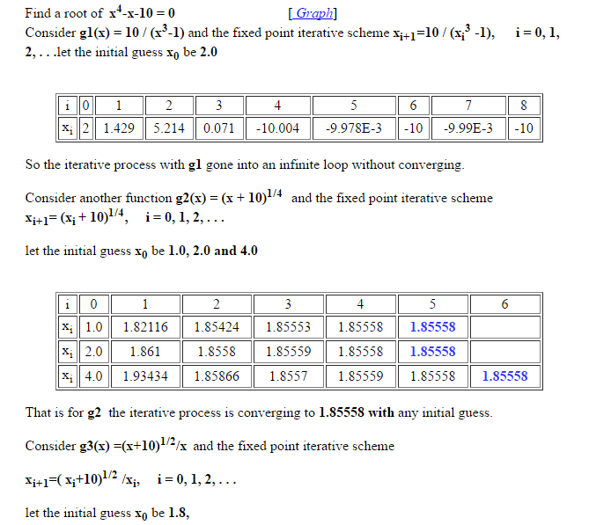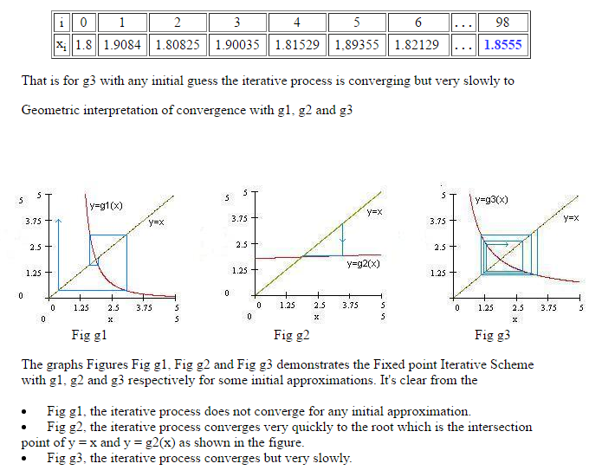



**Problem 02:**

Find the real root of the equation that lies on [3, 4] using fixed point iteration method.

**Solution:**

Let 

Now 





Hence there exist a root in (3, 3.5).

Now we rewrite the given equation in the following form:





Now Max 

Therefore  in (3, 3.5).

Then the iterative technique for fixed point iteration method is

, where 

Now let us start with the initial guess then successive approximation using fixed point iteration method are tabulated below.

|  |  |  |
| --- | --- | --- |
| Values of n | Values of |  |
|  | 3 | 3.098612289 |
|  | 3.098612 | 3.130954362 |
|  | 3.130954 | 3.141337866 |
|  | 3.141338 | 3.144648781 |
|  | 3.144649 | 3.145702209 |
|  | 3.145702 | 3.146037143 |
|  | 3.146037 | 3.146143611 |
|  | 3.146144 | 3.146177452 |

Since.

Hence the root of the given equation is equal to 3.1461.

**Problem 03:**

Find the real root of the equation that lies on [1, 2] using fixed point iteration method.

**Solution:**

Let 

Now 







Hence there exist a root in (1.5, 1.7).

Now we rewrite the given equation in the following form:





Now 

Therefore  in (1.5, 1.7).).

Then the iterative technique for fixed point iteration method is

, where 

Now let us start with the initial guess then successive approximation using fixed point iteration method are tabulated below.

|  |  |  |
| --- | --- | --- |
| Values of n | Values of |  |
|  | 1.5 | 1.594534892 |
|  | 1.594535 | 1.53341791 |
|  | 1.533418 | 1.572500828 |
|  | 1.572501 | 1.547332764 |
|  | 1.547333 | 1.563467349 |
|  | 1.563467 | 1.553093986 |
|  | 1.553094 | 1.559750939 |
|  | 1.559751 | 1.555473846 |
|  | 1.555474 | 1.558219777 |
|  | 1.55822 | 1.556455999 |
|  | 1.556456 | 1.557588559 |
|  | 1.557589 | 1.556861171 |
|  | 1.556861 | 1.557328276 |
|  | 1.557328 | 1.557028291 |

Since.

Hence the root of the given equation is equal to 1.557328.

**Problem 04:**

Find the real root of the equation that lies on [0, 1] using fixed point iteration method.

**Solution:**

Let 



Now 





Hence there exist a root in (0, 0.5).

Now we rewrite the given equation in the following form:





Now 

Therefore  in (0, 0.5).

Then the iterative technique for fixed point iteration method is

, where 

Now let us start with the initial guess then successive approximation using fixed point iteration method are tabulated below.

|  |  |  |
| --- | --- | --- |
| Values of n | Values of |  |
|  | 0.5 | 0.327026799 |
|  | 0.327026799 | 0.377578359 |
|  | 0.377578359 | 0.341867524 |
|  | 0.341867524 | 0.338731938 |
|  | 0.338731938 | 0.338983858 |
|  | 0.338983858 | 0.338223295 |

Since.

Hence the root of the given equation is equal to 0.338983858.

**Try yourself:**

**TYPE01:**

**To find the root of the following equations using** Iteration **method by** taking your ownguess**:**

1. 
2. 
3. 
4. 
5. 
6. 
7. 
8. 
9. 
10. 
11. 
12. 
13. 
14. 
15. 
16. 
17. 

**TYPE02:**

1. Find the root of by iteration method given that root lies near 1.
2. Find a real root  correct to three decimal places.
3. Find by iteration method the root near 3.8 of equation  correct to four decimal places.
4. Solve the equation by iteration method.
5. Find the real root the equation by the method of successive approximations.
6. Find the root of  which lies between 0.5 and 1 correct to four decimal places.
7. Show that the equation has exactly two real roots  and .
8. Find the positive real root of  correct to three decimal places.
9. Solve the equation for the positive root by iteration method.
10. Determine the real root of the equation  by iteration method.
11. Find the root of in [1,2] by fixed point iteration method taking  correct to five decimal places.
12. Use the method of iteration to find a positive root between 0 and 1 of the equation .
13. Compute a root of the equation  to an accuracy of ,using the iteration method.

**TYPE03:**

1. Derive the fixed point iteration method to solve the equation.
2. Write down the algorithm for fixed point iteration Method.
3. When does fixed point iteration Method Fails.

**Newton Raphson Method:**



Suppose we want to find a real root of the given equation that lies in .Consider be an arbitrary point which is very close to the desired root of the given equation .Draw a tangent to the curve at .Suppose this tangent makes an angle with x-axis at the point  where is the first approximation of the desired root.



On the other hand, the slope of the curve  at  is.



Therefore, from equation (i) and (ii) we have







If we say that is the desired root of the given equation.

Suppose that  .Now a draw a tangent to the curve at  which makes an angle with x-axis at the point where is the second approximation of the desired root .Consequently we have



On Simplification we have



In general the k-th approximation  can be computed by using the following iterative



We shall continue this iterative process until the value of two successive approximation are approximately equal.i.e or .

**Advantage of Newton Rapshon method:**

1. Converge fast if it converge to the root compare to another method.
2. Requires only one guess.
3. Convergence to the root quadratically.
4. Easy to convert to multiple dimentions.
5. Can be to polish a root found by another methods.

**Dis-advantage / drawback of Newton Rapshon method:**

1. Must find the derivative.
2. Poor global convergence properties.
3. It takes more computing time
4. It should never be used when the graph of is nearly horizontal where it crosses the x-axis.
5. Dependent on initial guess

* May be too far from local root
* May encounter a zero derivative
* May loop indefinitely

**Algorithm for Newton Rapson method:**

|  |  |
| --- | --- |
| **Steps** | **Task** |
| 01 | Define |
| 02 | Define |
| 03 | Read |
| 04 | Set |
| 05 |  |
| 06 | Calculate |
| 07 | If  then  GOTO Step 8  elseif  GOTO Step 5 |
| 08 | Print ,the desired root |
| 09 | STOP |

**Problem 01:**

**Find the root of the equation  by Newton-Rapshon Method correct to four decimal places.**

**Solution:**

**Let then .**

**Here  and **

Since  and are of opposite sign so at least one real root lies between 2 and 3.

**we know that from Newton-Rapshon method ,**



 [ putting values]





Choosing an initial guess ** and putting and  in above mentioned equation (1), we are capable to find the sccessive improved approrimations are as follows:**









Since so the Newton Rapshon method gives no new values of x and the approximate root is correct to four decimal places.Hence the require root is 2.2790 .

**Problem 02:**

**Using Newton-Rapshon method ,find the root of the equation which is nearer to correct to three decimal places.**

Solution:

**Let then .**

**Here  and **

Since  and are of opposite sign so at least one real root lies between 1 and 2.

**we know that from Newton-Rapshon method ,**









Choosing an initial guess ** and putting and  in above mentioned equation (1), we are capable to find the sccessive improved approrimations are as follows:**







Since so the Newton Rapshon method gives no new values of x and the approximate root is correct to five decimal places.Hence the require root is .

**Problem 03:**

**Find the real root of the equation correct to four decimal places using Newton-Rapshon method.**

**Solution:**

**Let  then .**

**Here  and  .**

**Hints: Calculator must be in radian Mode.**

Since  and are of opposite sign so at least one real root lies between -2 and -1.

**we know that from Newton-Rapshon method ,**









Choosing an initial guess ** and putting and  in above mentioned equation (1), we are capable to find the sccessive improved approrimations are as follows:**





Since so the Newton Rapshon method gives no new values of x and the approximate root is correct to two decimal places.Hence the require root is .

**Problem 04:**

**Find the root of the equation ,using Newton-Rapshom method.**

**Solution:**

**Let  then .**

**Here  and  .**

**Hints: Calculator must be in radian Mode.**

Since  and are of opposite sign so at least one real root lies between 2 and 3.

**we know that from Newton-Rapshon method ,**







Choosing an initial guess ** and putting and  in above mentioned equation (1), we are capable to find the sccessive improved approrimations are as follows:**





Since so the Newton Rapshon method gives no new values of x and the approximate root is correct to three decimal places.Hence the require root is .

**Try yourself:**

**TYPE01:**

**To find the root of the following equations using** Newton-Rapshon **method by** taking your ownguess**:**

1. 
2. 
3. 
4. 
5. 
6. 
7. 
8. 
9. 
10. 
11. 
12. 
13. 

**TYPE02:**

1. Find the real root of using Newton Raphson in (3, 4).
2. Using Newton Raphson Method find root of the equation that lies in (4, 5).
3. Using Newton Raphson Method find root of the equation in the interval (0, 1).
4. Find a real root of the equation by using Newton Raphson Method correct up to four decimal places.
5. Use Newton Raphson’s Method to find the root of with.
6. Find a real root of the equation by using Newton Raphson Method correct up to three decimal places.
7. Find a real root of the equation in [1,2] by using Newton Raphson Method correct up to five decimal places.
8. By using Newton Method find a real root of the equation which is near to x=2 correct up to three decimal places.
9. Find a real root of the equation  by using Newton Raphson Method correct up to four decimal places.
10. Find by using Newton Method the real root of the equation which is approximately 2 correct to three places of decimals.

**TYPE03:**

1. Using Newton Raphson Method establish the formula  to calculate the square root of N. Hence find the square root of 5 correct to four places of decimals.
2. Show that the iterative formula for finding the reciprocal of N is and hence find the value of 
3. Derive the iterative formula for Newton Raphson method to solve the equation.
4. Write down the merits and demerits of Newton Raphson Method.
5. Write down the algorithm for Newton Raphson Method.
6. When does Newton Raphson Method Fails.